Project XML – Cezmi & Tim

Tim 1-3-5

Cezmi 2-4-6

Q1) Is the attached XML file a well form document? Is it a valid document?  Name all XML elements and child elements.

A well-formed document in XML is a document that "adheres to the syntax rules specified by the XML 1.0 specification in that it must satisfy both physical and logical structures".

**Our Document is well formed as**

* All xml elements have closing tags
* They are case sensitive
* They are properly nested
* It has a root element
* Attribute values are in quotes

**Our Doc is also valid at this time**

* It has no DTD atm to check for validity but is valid when checking for syntax errors
* We will add a DTD and compare to that for validity
* In other words, it must be syntactically correct in order for it to be valid.

**All the XML elements and child elements**

* <orders>
* <order >
* <customerid>
* <status>
* <item>
* <name>
* <price>
* <qty>
* </item>
* </order>

Q2) Design the DTD for this document and link it to the given XML file.

Cezmi

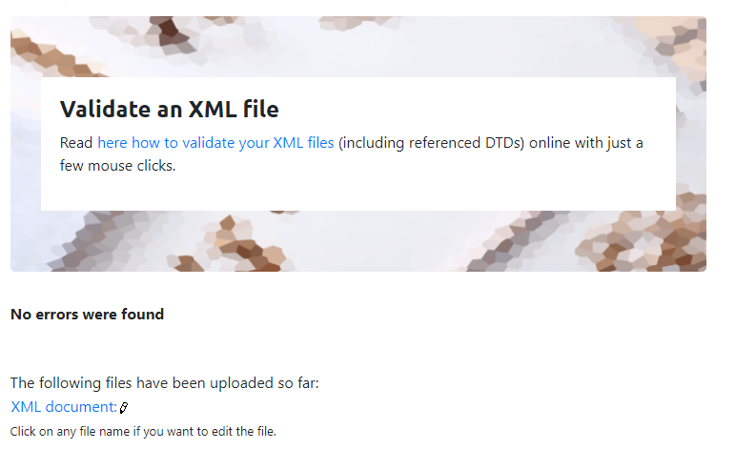

Q3) Design XML Schema for this document and link it to the given XML file.

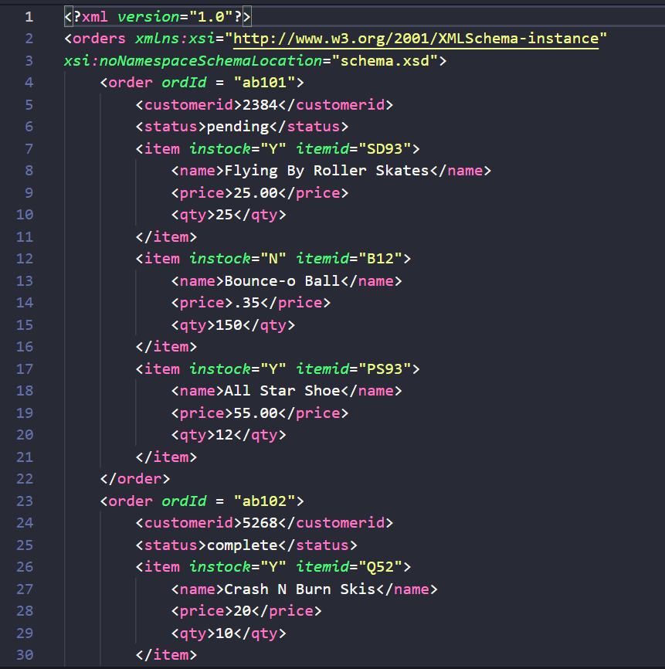

Q4) Write an XSLT document to transform order.xml into an HTML document that displays all orders in a HTML table format.

Cezmi

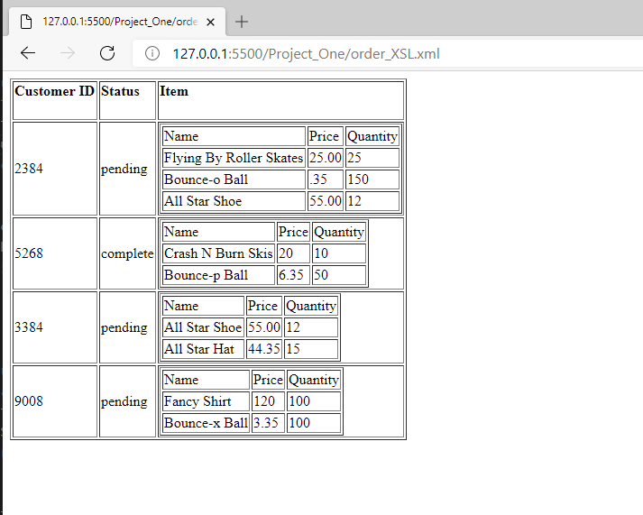

Q5) Write an XPATH query to show all order items which their instock = "N".

Design a new XSLT file that displays all records, but displays these items is red color.

//orders/order/item[@instock='N']

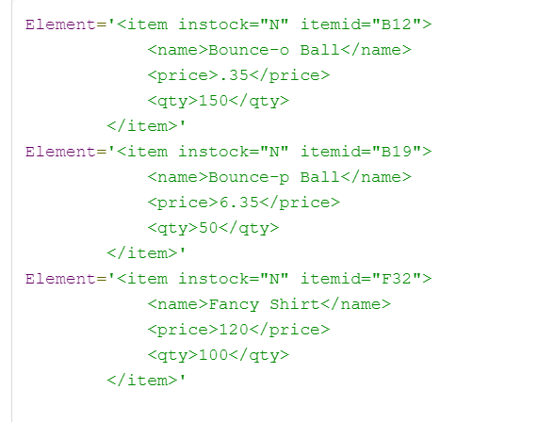

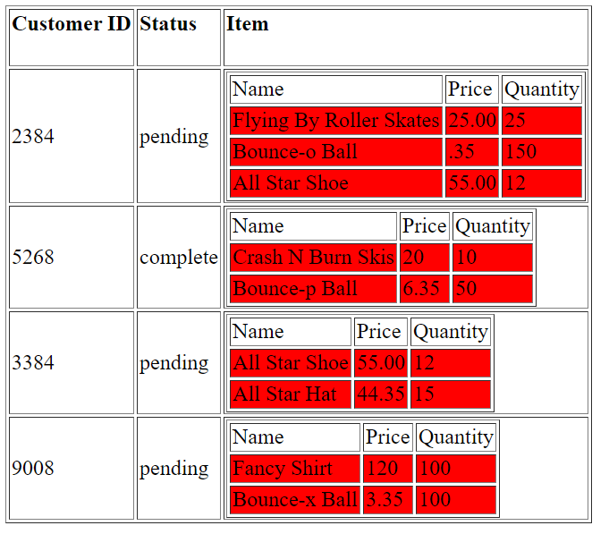

Q6) Using Q7.html, you need to develop a proper JavaScript function that will be invoked when a user clicks on the show pending orders. The JavaScript function processes the order.xml data and displays all "order_id, Custome_id, Item_id"  for those orders that their status are “pending”

